Featured Keynote Speakers for 2019 Global Innovation Summit
CAST-P
Susan Chang, PhD, Chair of Organizing Committee
(724) 2887467, scc@tasi-inc.com

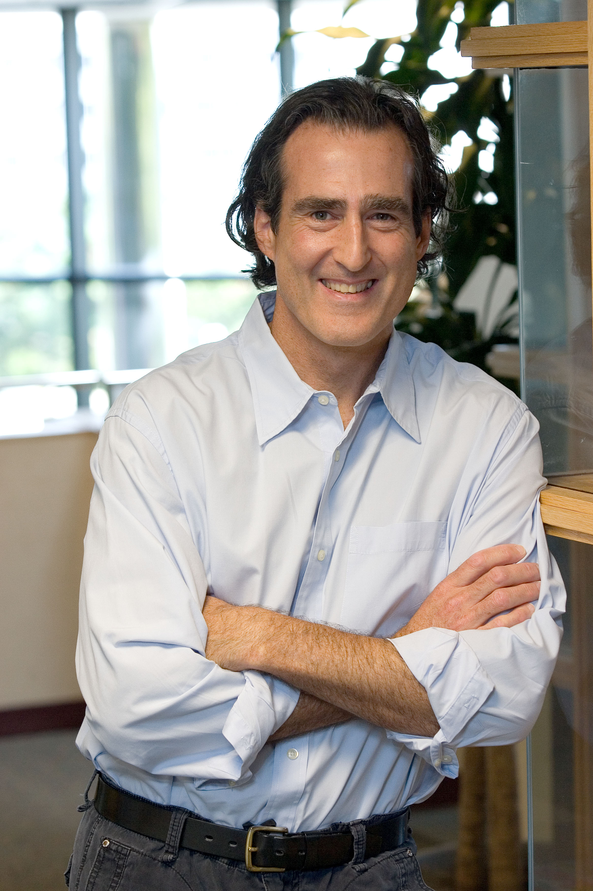

Professor Craig Mello, PhD, Nobel Prize of Physiology 2006. Blais University Chair in Molecular Medicine at the University of Massachusetts Medical School (UMMS)

Speech topic: A Worm’s Tale: RNA Memories and the Secrets of Inheritance and Immortality

His discovery of RNAi (RNA interference) with co-worker Andrew Fire, PhD received the recognition of 2016 Nobel Prize in Physiology to both of them.

Nobel Prize recipient Craig C. Mello, PhD, is the Blais University Chair in Molecular Medicine at the University of Massachusetts Medical School (UMMS). He was also designated an Investigator of the Howard Hughes Medical Institute in 2000, the third HHMI researcher selected at UMMS. HHMI is a $13 billion medical research organization that employs more than 350 eminent researchers at 72 medical schools, universities and research institutes worldwide.
Dr. Mello holds his BS in biochemistry from Brown University and his PhD in Cellular and Developmental Biology from Harvard University. He was a postdoctoral fellow at the Fred Hutchinson Cancer Research Center before coming to UMMS in 1995. He is also a 1995 Pew Scholar in the Biomedical Sciences.
Mello and his colleague Andrew Fire, PhD, formerly of the Carnegie Institution of Washington, received the 2006 Nobel Prize in Medicine for their discovery of RNA interference (RNAi). They demonstrated that a certain form of RNA had the unanticipated property of silencing—or interfering with—the expression of a gene whose coding sequence of DNA was similar to that of the RNA they tested. The RNAi mechanism—a natural response of an organism to double-stranded RNA, of which many viruses are comprised—destroys the gene products that a virus needs to replicate itself, essentially halting the progression of the invading viral infection.
The discovery, which offers astounding potential for understanding and manipulating the cellular basis of human disease, has had two extraordinary impacts on biological science. One is as a research tool: RNAi is now the state-of-the-art method by which scientists can knock down the expression of specific genes in cells, to thus define the biological functions of those genes. But just as important has been the finding that RNA interference is a normal process of genetic regulation that takes place during development. Thus, RNAi has provided not only a powerful research tool for experimentally knocking out the expression of specific genes, but has opened a completely new and totally unanticipated window on developmental gene regulation.
Mello and Fire’s work in RNAi, considered the formative paper on the topic in a 1998 edition of Nature, was hailed as “an electrifying discovery” and named the 2002 “Breakthrough of the Year” by Science magazine. In 2003, Mello and Fire received the prestigious National Academy of Sciences Award in Molecular Biology for their pioneering work as well as the Wiley Prize in the Biomedical Sciences from Rockefeller University; the fourth Annual Aventis Innovative Investigator Award at the Drug Discovery Technology World Conference; and, in 2004, the Warren Triennial Prize, the highest research honor bestowed by Massachusetts General Hospital.
In 2005, the team was named to the National Academy of Sciences and were recipients of several additional honors including Brandeis University’s Lewis S. Rosenstiel Award for Distinguished Work in Medical Research, the Canadian government’s Gairdner International Award and the Massry Prize. In 2006, the pair flew to Germany to accept the Paul Ehrlich and Ludwig Darmstaedter Prize, one of the highest and most internationally renowned awards conferred in the Federal Republic of Germany in the field of medicine. Most recently, Dr. Mello was named the inaugural recipient of The Dr. Paul Janssen Award for Biomedical Research by Johnson & Johnson.
Given the fundamental and broad-based impact of RNAi, a patent, “Genetic Inhibition by Double-Stranded RNA,” (US Patent 6,506,559 B1) issued to UMMS and Carnegie, is expected to have far-reaching licensing potential both in the lab and in drug development. Because both institutions were eager to bring RNAi to bear as broadly as possible to hasten genetic research, they developed a licensing policy by which companies can readily obtain, for a basic fee, a wide-ranging and non-exclusive license for scientists to use the technology for a reasonable cost.

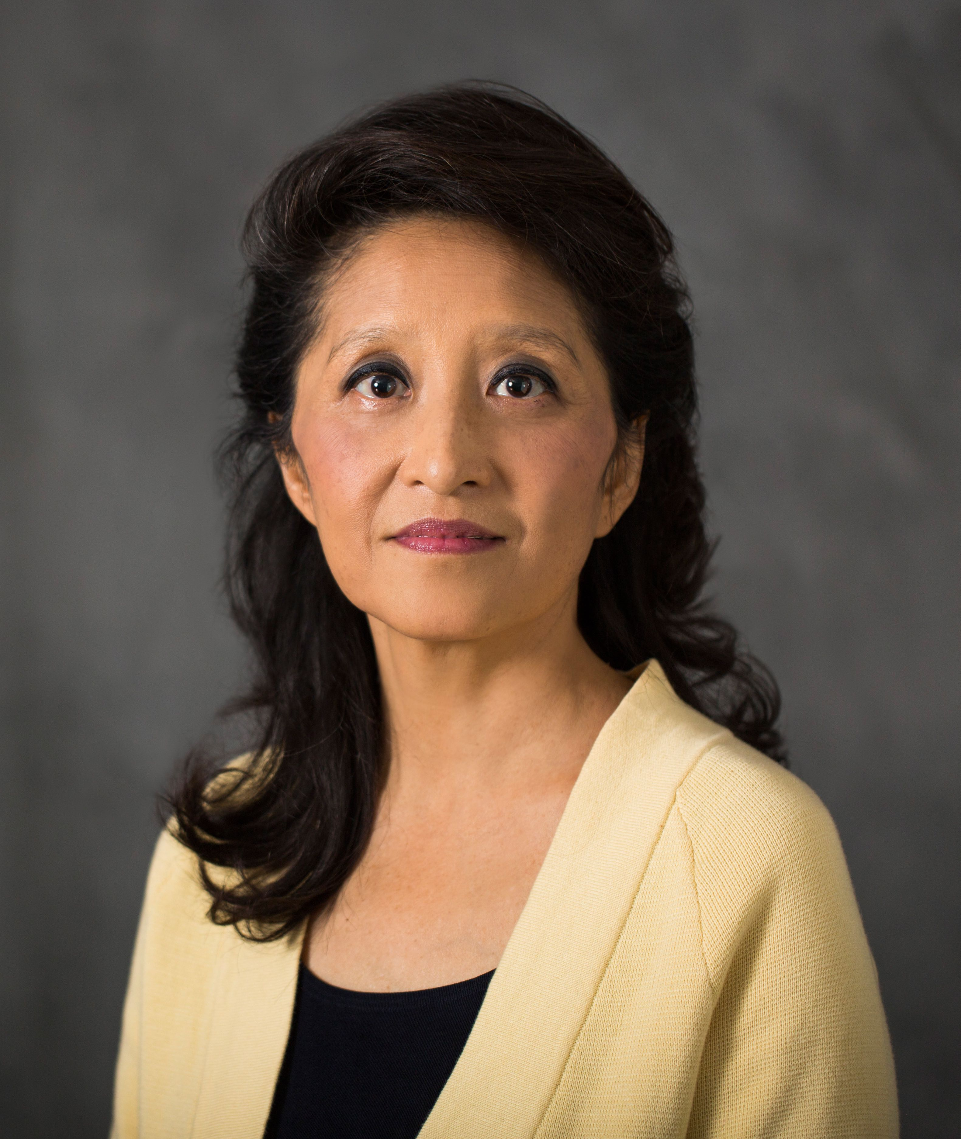

Yuan Chang, MD, Member of National Academy of Sciences. Distinguished Professor of Pathology and UPMC Endowed Chair in Cancer Virology at the University of Pittsburgh.
Speaking Topic: Human Oncogenic Viruses: Nature and Discovery
Dr. Chang identified the most recently discovered human tumor virus, Merkel cell polyomavirus (MCV).

Dr. Yuan Chang is a Distinguished Professor of Pathology and UPMC Endowed Chair in Cancer Virology at the University of Pittsburgh. She received her undergraduate degree from Stanford University, her M.D. degree from the University of Utah. In 1993, following completion of her Pathology training at UCSF and Stanford University, she joined the faculty at the Columbia University College of Physicians & Surgeons. In 1994, Dr. Chang co-discovered Kaposi’s sarcoma associated herpesvirus (KSHV/HHV8), with her husband Dr. Patrick S. Moore. In 2002, the Chang-Moore laboratory moved to the University of Pittsburgh and identified the most recently discovered human tumor virus, Merkel cell polyomavirus (MCV). Dr. Chang is an elected member of the US National Academy of Sciences, American Academy of Microbiology, and the American Society of Clinical Investigation. For their foundational discoveries in cancer etiology and pathogenesis, Chang and Moore have been the recipient of multiple honors including the Robert Koch Prize (Germany), the Mott Prize of the General Motors Cancer Research Foundation (USA), the Marjory Stephenson Prize (UK), and the Paul Ehrlich Prize (Germany).

TITLE: Human Oncogenic Viruses: Nature and Discovery
ABSTRACT: One in 5 cancers worldwide are caused by infection, most of which are caused by viruses. By understanding how a virus can turn a healthy cell into a cancerous cell, we gain critical insights into how the growth of any cancer cell is controlled. Our laboratory discovered two of the seven known human cancer viruses. In 1994, we isolated Kaposi sarcoma herpesvirus (KSHV or HHV8) that causes cancers among immune suppressed patients, especially persons with AIDS. In 2008, we discovered Merkel cell polyomavirus, which causes Merkel cell carcinoma, one the most aggressive forms of skin cancer. By studying the genes encoded by these viruses, we learn that these viruses target cellular pathways that control viral infections. But these pathways also control cancer cell proliferation and by inhibiting these pathways, these viruses can set the stage for a cancer to emerge

Manuel Blum, PhD, Bruce Nelson Professor of Computer Science Carnegie Mellon University
Turing Award Laureate 1995 In recognition of his contributions to the foundations of computational complexity theory and its application to cryptography and program checking.
Lenore Blum, PhD, Emeritus Distinguished Career Professor of Computer Science
2004 Presidential Award for Excellence in Science, Mathematics and Engineering Mentoring (PAESMEM)

Joint Speaking Topic: A Conscious AI
Manuel Blum was born in Caracas, Venezuela in 1938. He remembers that as a child he wanted to know how brains work. The reason: he wanted to be smarter. (“I was the opposite of a prodigy," he claims). At M.I.T. he studied electrical engineering because he thought electric circuits might hold the answer. As a junior he studied brains in Warren McCulloch's lab. Eventually he became convinced that the limitations of our brain are related to computational complexity, and that is how he embarked on a life-long journey that transformed that subject as well as much of computer science.
By the early 1960s computers were already solving all kinds of problems in business and science. An algorithm for solving a problem expends resources: the time it takes to run, the amount of memory it uses, the energy it consumes, etc. The irresistible question is: Can I do better? Can I find an algorithm that solves the problem faster using fewer resources? You can sort n numbers in a computer's memory with n log n comparisons using Mergesort, Quicksort or a similar sorting algorithm. But can it be done better? You can find the factors of an n-bit integer in time proportional to 2n/2 by checking all candidate divisors up to the square root of the number. But this is exponential in n. Is there a better, truly fast algorithm? You can search a maze with n corridors using only log2n memory. Is there a solution utilizing log n memory? This is the stuff of complexity.
Of the three questions above, after half a century of contemplation we know the answer to only the first one, about sorting: An elementary argument discovered in the 1960s establishes that you cannot sort with fewer than n log n comparisons. (This is proved by considering the decision tree of a sorting algorithm and then taking the logarithm of its size). So sorting a list of n numbers requires n log n time.
Computing the average of a list of numbers is, of course, easier than sorting, since it can be done in just n steps. But the median is usually more informative than the average–in connection with incomes, for example. Unfortunately you need to first sort the numbers in order to find the median. Or do you? In the late 1960s, Blum was convinced that computing the median does indeed require n log n steps, just like sorting. He tried very hard to prove that it does, and in the end his labors were rewarded with a most pleasant surprise: in 1971 he came up with an algorithm that finds the median in linear time! (A few other great researchers had in the meantime joined him in this quest Robert Tarjan, Ronald Rivest, Bob Floyd, and Vaughan Pratt.) [2]
But we are getting ahead of our story. In the early 1960s Blum wanted to understand complexity. To do so one must first pick a specific machine model on which algorithms run, and then a resource to account for in each computation. But Blum wanted to discover the essence of complexity–its fundamental nature that lies beyond such mundane considerations. In his doctoral thesis at M.I.T. under Marvin Minsky, he developed a machine-independent theory of complexity that underlies all possible studies of complexity. He postulated that a resource is any function that has two basic properties (since then called the Blum axioms), essentially stating that the amount of the resource expended by a program running on a particular input can be computed—unless the computation fails to halt, in which case it is undefined.
Surprisingly these simple and uncontroversial axioms spawn a rich theory full of unexpected results. One such result is Blum’s speedup theorem, stating that there is a computable function such that any algorithm for this function can be sped up exponentially for almost all inputs [1]. That is, any given algorithm for that function can be modified to run exponentially faster, but then the modified algorithm can be modified again, and then again, an infinite sequence of exponential improvements! Blum's theory served as a cautionary tale for complexity theorists: unless resource bounds are restricted to the familiar, well-behaved ones (such as n log n, n2, polynomial, exponential, etc.), very strange things can happen in complexity.
By the early 1970s Manuel Blum was a professor at UC Berkeley, where he would teach for over thirty-five years. He had married the notable mathematician Lenore Blum, about whom Manuel wrote a haiku: “Honor her requests as if/Your life depends on it/It does." They had a son Avrim, now a professor of Computer Science at Carnegie Mellon, where Lenore and Manuel are also now employed.
By the early 1970s the study of complexity had become much more concrete, partly because of the scary phenomena exposed by Blum's model. It had already succeeded in articulating the fundamental P vs NPquestion, which remains famously unresolved to this day: are there problems which can only be solved by rote enumeration of all possible solutions? At that point, when most students of complexity embarked on a long-term research effort aiming at either taming the beast, or establishing that all such efforts are futile, Blum's thinking about the subject took a surprising turn that would constitute the overarching theme of his work for the coming decades: he decided to make friends with complexity, to turn the tables on it, and use it to accomplish useful things.
One particular such “application” of complexity was emerging just around that time: public key cryptography, which allows secure communication through the use of one-way functions that are easy to compute but hard to reverse. It so happened that in the mid-1970s Blum decided to spend a sabbatical studying number theory—the beautiful branch of mathematics theretofore famously proud of its complete lack of application. Nothing could be more fortuitous. The RSA approach to public key cryptography, which was being invented around that time, exploits important one-way functions inspired by number theory. RSA's inventors Ron Rivest, Adi Shamir, and Len Adleman (the latter a doctoral student of Blum's) won the Turing award in 2003 for this idea.
Blum wondered what else complexity can help us with beyond cryptography. One strange thought came to him: can two people, call them Alice and Bob, settle an argument over the telephone about, say, who is buying drinks next time, by flipping a coin? This seems impossible, because who is going to force the one who flips, for example, Bob, to admit that he lost the toss? Surprisingly, Blum showed [3] that it can be done: Alice “calls” the flip by announcing to Bob not her choice, but some data which commits her to her choice. Then Bob announces the outcome of the flip, and they both check whether the committing data reveals a choice that wins or loses the flip. The notion of commitment (Alice creating a piece of data from a secret bit that can later be used, with Alice's cooperation, to reveal the bit in a way that can neither be manipulated by Alice nor questioned by Bob) has since become an important tool in cryptography.
Perhaps the most consequential application of complexity initiated by Manuel Blum relates to randomness. We often use pseudo-random number generators to instill randomness into our computations. But to what extent are the numbers generated truly random, and what does this mean, exactly? Blum's idea was that the answer lies in complexity. Distinguishing the output of a good generator from a truly random sequence seemed be an intractable problem, and many random number generators that were popular at the time fail this test. In 1984, Blum and his student Silvio Micali came up with a good generator [4] based on another notoriously difficult problem in number theory, the discrete logarithm problem. With Lenore Blum and Michael Shub they found another generator [5] }using repeated squaring modulo the product of two large primes. To discover the seed, the adversary must factor the product, and we know that this is a hard problem.
On top of all this, Blum demonstrated that cryptographically strong pseudorandom generators can pay back their intellectual debt to cryptography. He and student Shafi Goldwasser came up in 1986 with a public key encryption scheme [6] based on the Blum-Blum-Shub generator [5] which, unlike RSA, has been mathematically proven to be as hard to break as factoring.
In the mid-1980s, Blum became interested in the problem of checking the correctness of programs. Given a program that purports to solve a particular problem, can you write a program checker for it: an algorithm that interacts with the program and its input, and eventually decrees (in reasonable time and with great certainty) whether or not the program works correctly. Checkability turns out to be a windfall of complexity, and Manuel and his students Sampath Kannan and Ronitt Rubinfeld were able to come up with some interesting checkers [7]. They used the tricks of their trade: randomness, reductions, and algebraic maneuvers reminiscent of coding theory.
All said, this work was not very successful in helping software engineers in making a dent into the practical problem of software testing. Instead, it serendipitously inspired other theoreticians to come up with more clever tricks of this sort, and eventually use them—closing a full circle—in the study of complexity. The concept of interactive proof was proposed, whereby an all-powerful prover can convince a distrustful but limited checker that a theorem is true (just as a program interacts with its checkers to convince it of its correctness), and such proof systems were demonstrated for truths at higher and higher spheres of complexity. And, finally, in 1991, this long chain of ideas and results—this intellectual Rube Goldberg structure initiated by Blum's ideas about program checking—culminated with the famed PCP (Probabilistically checkable proof) Theorem stating that any proof can be rewritten in such a way that its correctness can be tested with high confidence by quickly examining for consistency just a few bits of the proof! Importantly, the PCP theorem implies a result which had been long sought by complexity theorists, namely that, assuming that P is not NP, not only can we not solve the notorious NP-complete optimization problems exactly in polynomial time, we cannot even approximately.
In the mid-1990s, Manuel and Lenore Blum went to Hong Kong for a long sabbatical, and soon after that Manuel decided to retire from UC Berkeley and move to CMU. At CMU, Blum envisioned a new use for complexity, motivated by the vagaries of our networked environment: What if one takes advantage of the complexity of a problem—and the difficulty involved in solving it by a computer program—to verify that the solver is not a computer program? This kind of twisted Turing test would be useful, for example, in making sure that the new users signing up for a web service are not mischievous bots with base intentions. In 2000 Blum and his student Von Ahn, with the collaboration of others, came up with the idea of a visual challenge (“what is written on this wrinkled piece of paper?”) as an appropriate test. They called it “Completely Automated Public Turing test to tell Computers and Humans Apart,” or CAPTCHA for short [8]. And, as we all know all too well from our encounters with this CAPTCHA device on web pages, the idea spread. Blum is now working on harnessing people's creativity through games, and on a computational understanding of consciousness.
The research career of Manuel Blum is extraordinary. It is not just the sheer number and impact of his contributions, it is the unmistakable style that runs through them. Manuel believes that research results should be surprising, paradoxical, and nearly contradictory. “When you can prove that a proposition is true, and also that the same proposition is false, then you know you are on to something,” he says. A wonderful advisor with an amazing array of former students, he is always delighted to impart wisdom. His “advice to a new graduate student" essay is a must-read. Quoting Anatole France, he implores students to “know something about everything and everything about something.” He urges them to read books as random access devices, not necessarily from beginning to end. And to write: if we read without writing, he observes, we are reduced to finite state machines; it is writing that makes us all-powerful Turing machines. He advocates the advice of John Shaw Billings: “First, have something to say. Second, say it. Third, stop when you have said it.”

Lenore Blum, PhD
Emeritus Distinguished Career Professor of Computer Science, Carnegie Mellon University

Lenore Blum (Ph.D., MIT) is Emeritus Distinguished Career Professor of Computer Science at Carnegie Mellon, where she was founding director of Project Olympus, faculty director of the Swartz Center for Entrepreneurship, and held the inaugural Deans’ Chair in Technology Entrepreneurship. Project Olympus is a good example of her determination to make a real difference in the academic community and the world beyond. Olympus has two main aims: to bridge the gap between cutting-edge university research/innovation and economy-promoting commercialization for the benefit of our communities and creating a climate, culture and community to enable talent and ideas to grow in the region.

Lenore is internationally recognized for her work in increasing the participation of girls and women in Science, Technology, Engineering and Math (STEM) fields. She was a founder of the Association for Women in Mathematics and the Expanding Your Horizons Network. At Carnegie Mellon she founded the Women@SCS program. In 2004 she received the U.S. Presidential Award for Excellence in Science, Mathematics and Engineering Mentoring. In 2009 she received the Carnegie Science Catalyst Award recognizing her work with Project Olympus targeting high-tech talent to promote economic growth in the Pittsburgh region and for increasing the participation of women in computer science. Currently, women comprise 50% of the undergraduate computer science majors at Carnegie Mellon, more than twice the national average.

Her research, founding a theory of computation and complexity over continuous domains, forms a theoretical basis for scientific computation. On the eve of Alan Turing’s 100th birthday in June 2012, she was plenary speaker at the Turing Centenary Celebration at the University of Cambridge, England. Her current research, on developing a computer architecture for a conscious AI inspired both by Alan Turing and recent developments in cognitive neuroscience, is joint with her husband Manuel Blum and son Avrim Blum.

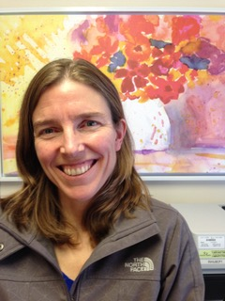

Dr. Selena Lawrie is a Family Physician who lives with her 4 teenage children in Kamloops, BC, Canada. She is passionate about working with people, communities and governments to improve individual and population health and wellness. Her clinical work has included over 2 decades of broad scope family medicine from rural to urban, in-hospital, maternity, indigenous and community care. She was the founding Site Director of the University of British Columbia Family Practice Residency Training Program in Kamloops, as well as the founder and former President of Supporting Team Excellence with Patients Society. She was also instrumental in the development of the UBC Family Practice Learning Centre in Kamloops. She is currently a Board Member of the BC Interior Health Authority, a member of the steering committee for the BC Physicians Health Program, and a member of the BC Primary and Community Care Research Advisory Committee. Dr. Lawrie is the great-great grand-daughter of George Westinghouse.

